NHSSP KS2 Learn to Ride Workshop

Age groups / categories

Key Stage 2 – Years 3 - 6

Team

Schools can bring up to 10 pupils to attend a 1-hour time slot

This workshop is aimed at any pupils struggling to ride a bike

They might be struggling with a 2-wheel bike – either not pedalling yet or have stabilisers, etc. or if they have a disability meaning they require an adapted bike, just let us know.

Format

Led by the Herts Disability Sports Foundation and Herts Cycling team, instructors will work on basic skills appropriate to the individuals.

The session will take place on an enclosed concrete area.

All helmets (must be worn) and bikes will be provided. The first 10 minutes will be sizing the participant up with an appropriate bike.

All schools will receive information about follow-up sessions if required or requested and about additional holiday activities available for pupils.

Progression

There is no progression on from this workshop

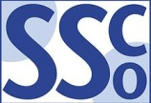
NHSSP KS2 Learn to Ride Workshop

Registration Sheet

School name
Lead member of staff
Participation data
Gender¹
Boys - |  | Girls - | Other -
Ethnicity²
White (British/English) - | White (not British/English) - |  |  | Mixed Race -
Asian or British Asian - | Back or Black British - |  |  | Other -
SEND³
Total -

Please bring this sheet along with you and hand in to the event organiser upon arrival.

Be sure to let the event organiser know whether you have any pupils that cannot have their photograph taken. Photos are put onto the NHSSP website and twitter feed.

- We require data relating to gender at birth, or the child’s self-declared gender identity (if known and if different from birth-gender): i.e. a child born as a boy but identifying as a girl should be classified as a girl. “Other” should include those who prefer to self-describe as neither a boy or a girl, e.g. non-binary, gender-fluid and gender non-conforming.
- We require participation data relating to background and race to ensure that we reach a diverse population across School Games. We encourage all SGOs to collect and use data at a more granular level to help identify local opportunities and gaps and to ensure that an offer of a wide, diverse and inclusive provision for all. This data can be obtained from participating schools at an aggregated level, subject to data sharing agreements i.e. schools should be asked to share the total number of children participating in an event within each of the 6 groups.
- We require data at an overall “Special Educational Needs and/or Disability (SEND)” level for reporting purposes. However, we encourage SGOs to collect and use data at a more granular level to ensure a wide and diverse set of participants and inclusive provision. This data can be obtained from participating schools, subject to their data sharing agreements. Children included within the wide description of “SEND” include those with physical, cognitive, mental health/emotional and communication/social/relationships disabilities.

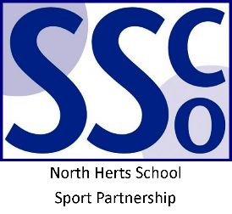
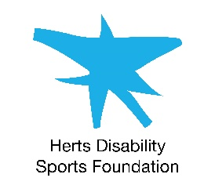

<Pupil Name>

Participated in the North Herts School Sport Partnership
School Games Learn to Ride Workshop

North Herts School Sport Partnership

www.nhssp.co.uk | @NorthHertsSSP

<Pupil Name>

Participated in the North Herts School Sport Partnership
School Games Learn to Ride Workshop

North Herts School Sport Partnership

www.nhssp.co.uk | @NorthHertsSSP

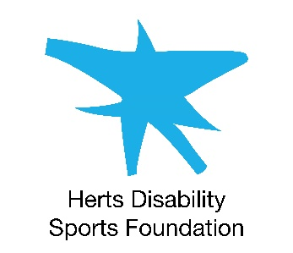
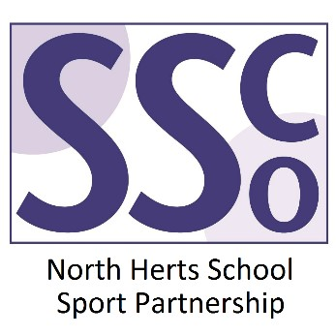

<School Name>

Participated in the North Herts School Sport Partnership
School Games Learn to Ride Workshop

www.nhssp.co.uk | @NorthHertsSSP

