NHSSP Badminton

Age groups / categories

U9 – Year 3 or 4
U14 – Years 7, 8 or 9
U16 – Years 10 or 11

Available to enter:

- U9 Mixed Racket Pack Festival
- U14 Boys Competition
- U14 Girls Competition
- U16 Boys Competition
- U16 Girls Competition

Team

U9
Teams consist of 8 players

U14 and U16
Teams consist of 4 players per age group / category

Format

U9
Racket Pack Festival – teams rotate around 10 different badminton skill activities. There will be no formal competition or overall winners.

U14 and U16
If time, each match will consist of 5 games: 2 x singles and 3 x doubles, with each player playing 2 games:

1st Game: Singles (No.1 ranked player in the team)
2nd Game: Doubles (the 2 players not selected for a singles game)
3rd Game: Singles (No. 2 or 3 ranked player chosen for singles)
4th Game: Doubles (first singles player + either one of non-singles players)
5th Game: Doubles (second singles player + the other non-singles player)

Each game will be 1 set to 11 points. To save time, at 10 all, the player to gain the next point wins the set (rather than having to gain a 2-point advantage). Group winners are decided by most matches won then most points won. If 2 teams are still tied the decision is based on the winner of the match between them.

Rules

U9
Schools can access for free The Racket Pack resource which can help prepare the children for competition. By delivering the programme in school children can further develop their physical literacy along with the confidence to perform these skills.

U14 and U16
At the beginning of the game and when the servers score is even, serve from the right service court
When the servers score is odd, serve from left service court
If server wins a rally, they get a point and serve again from alternate service court (in doubles, the server stays the same but moves to alternate service court)
If the receiver wins a rally, receiver scores a point and becomes new server

Progression

U9
No progression

U14 and U16
Winning teams from each age group and category will be invited to represent Team North Herts at the Herts School Games Finals.

The U9 Racket Pack Festival is an Aspire and Develop Event

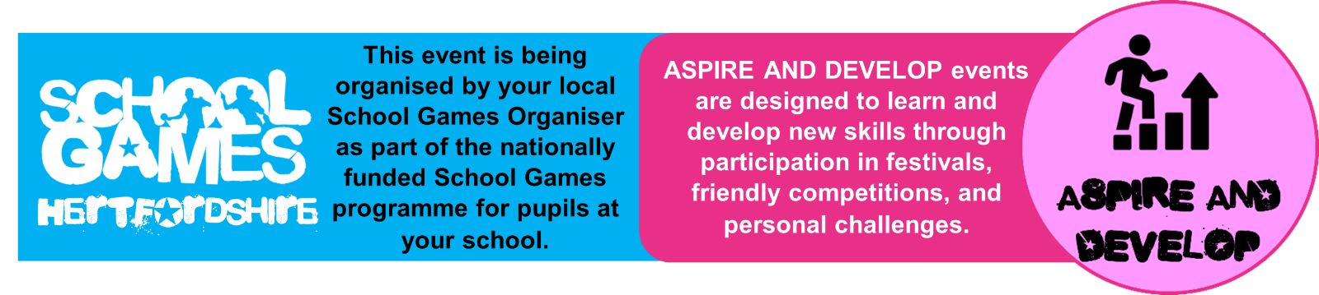

The U14 and U16 Competitions are Compete Events

NHSSP Badminton

Registration Sheet

School name
Lead member of staff
Participation data
Gender¹
Boys - |  | Girls - | Other -
Ethnicity²
White (British/English) - | White (not British/English) - |  |  | Mixed Race -
Asian or British Asian - | Back or Black British - |  |  | Other -
SEND³
Total -

Please bring this sheet along with you and hand in to the event organiser upon arrival.

Be sure to let the event organiser know whether you have any pupils that cannot have their photograph taken. Photos are put onto the NHSSP website and twitter feed.

- We require data relating to gender at birth, or the child’s self-declared gender identity (if known and if different from birth-gender): i.e. a child born as a boy but identifying as a girl should be classified as a girl. “Other” should include those who prefer to self-describe as neither a boy or a girl, e.g. non-binary, gender-fluid and gender non-conforming.
- We require participation data relating to background and race to ensure that we reach a diverse population across School Games. We encourage all SGOs to collect and use data at a more granular level to help identify local opportunities and gaps and to ensure that an offer of a wide, diverse and inclusive provision for all. This data can be obtained from participating schools at an aggregated level, subject to data sharing agreements i.e. schools should be asked to share the total number of children participating in an event within each of the 6 groups.
- We require data at an overall “Special Educational Needs and/or Disability (SEND)” level for reporting purposes. However, we encourage SGOs to collect and use data at a more granular level to ensure a wide and diverse set of participants and inclusive provision. This data can be obtained from participating schools, subject to their data sharing agreements. Children included within the wide description of “SEND” include those with physical, cognitive, mental health/emotional and communication/social/relationships disabilities.

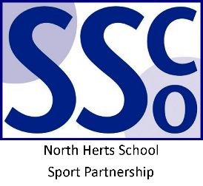

<Pupil Name>

Participated in the North Herts School Sport Partnership
School Games Badminton Event

North Herts School Sport Partnership

www.nhssp.co.uk | @NorthHertsSSP

<Pupil Name>

Participated in the North Herts School Sport Partnership
School Games Badminton Event

North Herts School Sport Partnership

www.nhssp.co.uk | @NorthHertsSSP

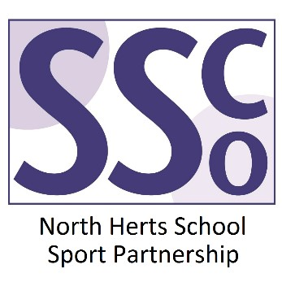

<School Name>

Participated in the North Herts School Sport Partnership
School Games Badminton Event

www.nhssp.co.uk | @NorthHertsSSP

