NHSSP U9 Golfway Competition

Age groups / categories

U9 – Year 3 or 4

Available to enter:

- Mixed U9

Team

Full teams consist of 10 players (5 boys and 5 girls*)
*with the exception for all girls schools

Format

8-game Golfway Skills Competition Format
There will be 8 games and two bunker rest stops
2 tees per game station to allow more turns per player
5 pupils per tee (10 players on each game station)
2 minutes practice time and 5 minutes scoring time on each game
Schools will also be given a score per station based on their demonstration of the School Games Values (Passion, Self-Belief, Respect, Honesty, Determination and Teamwork)

Rules

8 games are as follows:
- Bullseye
- Dominos
- Drive for show, putt for dough
- Finders keepers
- Grand national
- Tunnel ball
- Zone ball
- Go for the green

See individual game instructions here.

Progression

The winning team will be invited to represent Team North Herts at the Herts School Games Finals.

NHSSP U9 Golfway Competition

Registration Sheet

School name
Lead member of staff
Participation data
Gender¹
Boys - |  | Girls - | Other -
Ethnicity²
White (British/English) - | White (not British/English) - |  |  | Mixed Race -
Asian or British Asian - | Back or Black British - |  |  | Other -
SEND³
Total -

Please bring this sheet along with you and hand in to the event organiser upon arrival.

Be sure to let the event organiser know whether you have any pupils that cannot have their photograph taken. Photos are put onto the NHSSP website and twitter feed.

- We require data relating to gender at birth, or the child’s self-declared gender identity (if known and if different from birth-gender): i.e. a child born as a boy but identifying as a girl should be classified as a girl. “Other” should include those who prefer to self-describe as neither a boy or a girl, e.g. non-binary, gender-fluid and gender non-conforming.
- We require participation data relating to background and race to ensure that we reach a diverse population across School Games. We encourage all SGOs to collect and use data at a more granular level to help identify local opportunities and gaps and to ensure that an offer of a wide, diverse and inclusive provision for all. This data can be obtained from participating schools at an aggregated level, subject to data sharing agreements i.e. schools should be asked to share the total number of children participating in an event within each of the 6 groups.
- We require data at an overall “Special Educational Needs and/or Disability (SEND)” level for reporting purposes. However, we encourage SGOs to collect and use data at a more granular level to ensure a wide and diverse set of participants and inclusive provision. This data can be obtained from participating schools, subject to their data sharing agreements. Children included within the wide description of “SEND” include those with physical, cognitive, mental health/emotional and communication/social/relationships disabilities.

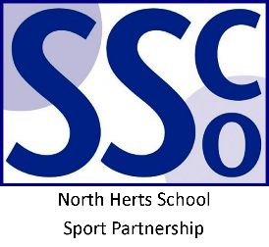

<Pupil Name>

Participated in the North Herts School Sport Partnership
School Games U9 Golfway Competition

North Herts School Sport Partnership

www.nhssp.co.uk | @NorthHertsSSP

<Pupil Name>

Participated in the North Herts School Sport Partnership
School Games U9 Golfway Competition

North Herts School Sport Partnership

www.nhssp.co.uk | @NorthHertsSSP

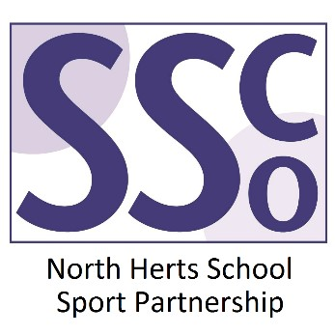

<School Name>

Participated in the North Herts School Sport Partnership
School Games U9 Golfway Competition

www.nhssp.co.uk | @NorthHertsSSP

