NHSSP U9 Tennis Competition

Age groups / categories

U9 – Year 3 or 4

Available to enter:

- Mixed U9

Team

Full teams consist of 4 players (2 boys and 2 girls*)
*with the exception for all girls schools
Players should be ranked 1 – 4 (1 being the most able player)

Format

Each full match will comprise of the following games:

Rank 1 v Rank 1
Rank 2 v Rank 2
Rank 3 v Rank 3
Rank 4 v Rank 4

Players must play in this order throughout each of the matches. All players will only play singles matches. Games are the first to 7 points, at 6-6 only one further point will be played.
To help children learn the scoring system you can be inventive with different counting to 7 tasks such as: for each point won place a peg on your allocated side of the net or place bean bag in your hoop. The first to collect 7 wins.
Matches take approximately 10 minutes each to play. Match winners are decided on the most points won.
Group winners are decided on the number of matches won. If two teams are tied, it will come down to the result between those two teams. If more than two teams are tied, it will come down to total number of points scored.

Rules

A sponge ball is used for the indoor competition.
The service is decided by a ‘toss’ at the start of the match.
The nominated person serves for the first point from the right side of the court, it then alternates every 2 points; first from the left court, and then from the right court.
When serving, the player should stand behind the baseline and the ball must not be bounced before being hit. The service can be hit over or underarm. Serves should be hit diagonally, landing in the diagonally opposite service box. The ball must land in the service box.

Progression

The winning team will be invited to represent Team North Herts at the Herts School Games Finals.

NHSSP U9 Tennis Competition

Registration Sheet

School name
Lead member of staff
Participation data
Gender¹
Boys - |  | Girls - | Other -
Ethnicity²
White (British/English) - | White (not British/English) - |  |  | Mixed Race -
Asian or British Asian - | Back or Black British - |  |  | Other -
SEND³
Total -

Please bring this sheet along with you and hand in to the event organiser upon arrival.

Be sure to let the event organiser know whether you have any pupils that cannot have their photograph taken. Photos are put onto the NHSSP website and twitter feed.

- We require data relating to gender at birth, or the child’s self-declared gender identity (if known and if different from birth-gender): i.e. a child born as a boy but identifying as a girl should be classified as a girl. “Other” should include those who prefer to self-describe as neither a boy or a girl, e.g. non-binary, gender-fluid and gender non-conforming.
- We require participation data relating to background and race to ensure that we reach a diverse population across School Games. We encourage all SGOs to collect and use data at a more granular level to help identify local opportunities and gaps and to ensure that an offer of a wide, diverse and inclusive provision for all. This data can be obtained from participating schools at an aggregated level, subject to data sharing agreements i.e. schools should be asked to share the total number of children participating in an event within each of the 6 groups.
- We require data at an overall “Special Educational Needs and/or Disability (SEND)” level for reporting purposes. However, we encourage SGOs to collect and use data at a more granular level to ensure a wide and diverse set of participants and inclusive provision. This data can be obtained from participating schools, subject to their data sharing agreements. Children included within the wide description of “SEND” include those with physical, cognitive, mental health/emotional and communication/social/relationships disabilities.

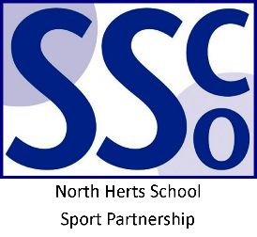

<Pupil Name>

Participated in the North Herts School Sport Partnership
School Games U9 Tennis Competition

North Herts School Sport Partnership

www.nhssp.co.uk | @NorthHertsSSP

<Pupil Name>

Participated in the North Herts School Sport Partnership
School Games U9 Tennis Competition

North Herts School Sport Partnership

www.nhssp.co.uk | @NorthHertsSSP

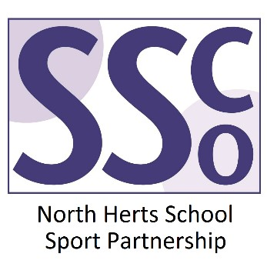

<School Name>

Participated in the North Herts School Sport Partnership
School Games U9 Tennis Competition

www.nhssp.co.uk | @NorthHertsSSP

