NHSSP U11 Basketball Competition

Age groups / categories

U11 – Years 5 or 6

Available to enter:

- U11 Girls
- U11 Boys

Team

Teams consist of 4 players per category - a full team is made up of 4 boys and 4 girls

Format

4 players will be on court playing at a time - 4 boys will play the first period; 4 girls will play the second
A size 5 ball will be used in line with FIBA regulations for U11
The game will comprise of two periods, timings dependent upon entries
The team fouls penalty will apply after 4 fouls in the game
There will be a 1-minute interval between each period
Overtime (if required) will be two minutes using the stopping clock rules

Rules

Game duration will depend on the number of entries and facility availability.
Games start with a jump ball.
Either team may substitute a player whenever the ball is out of play.
At a change of possession (foul, basket, ball out of play) play should restart from the nearest side/end line.
Any player persistently fouling may be removed from the game by the referee.
In the event of a foul the opposing team will receive the ball on the nearest side/end line. If the player is fouled in the act of shooting one/ two free throws are rewarded; one if the basket is scored and two if the shot is missed. Each free throw is worth one point.
When a team scores, the other team gain possession of the ball on the end line.
Points will be awarded at 3 points for a win, 2 points for a draw and 1 for a loss.
When teams are tired on points the game played between the two teams will decide their placing in the league. If this does not produce a result the balance of baskets scored to baskets conceded will decide the result.

Progression

Winning teams from each category will be invited to represent Team North Herts at the Herts School Games Finals.

NHSSP U11 Basketball Competition

Registration Sheet

School name
Lead member of staff
Participation data
Gender¹
Boys - |  | Girls - | Other -
Ethnicity²
White (British/English) - | White (not British/English) - |  |  | Mixed Race -
Asian or British Asian - | Back or Black British - |  |  | Other -
SEND³
Total -

Please bring this sheet along with you and hand in to the event organiser upon arrival.

Be sure to let the event organiser know whether you have any pupils that cannot have their photograph taken. Photos are put onto the NHSSP website and twitter feed.

- We require data relating to gender at birth, or the child’s self-declared gender identity (if known and if different from birth-gender): i.e. a child born as a boy but identifying as a girl should be classified as a girl. “Other” should include those who prefer to self-describe as neither a boy or a girl, e.g. non-binary, gender-fluid and gender non-conforming.
- We require participation data relating to background and race to ensure that we reach a diverse population across School Games. We encourage all SGOs to collect and use data at a more granular level to help identify local opportunities and gaps and to ensure that an offer of a wide, diverse and inclusive provision for all. This data can be obtained from participating schools at an aggregated level, subject to data sharing agreements i.e. schools should be asked to share the total number of children participating in an event within each of the 6 groups.
- We require data at an overall “Special Educational Needs and/or Disability (SEND)” level for reporting purposes. However, we encourage SGOs to collect and use data at a more granular level to ensure a wide and diverse set of participants and inclusive provision. This data can be obtained from participating schools, subject to their data sharing agreements. Children included within the wide description of “SEND” include those with physical, cognitive, mental health/emotional and communication/social/relationships disabilities.

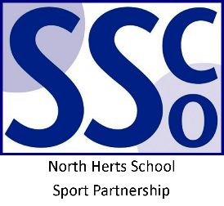

<Pupil Name>

Participated in the North Herts School Sport Partnership
School Games U11 Basketball Competition

North Herts School Sport Partnership

www.nhssp.co.uk | @NorthHertsSSP

<Pupil Name>

Participated in the North Herts School Sport Partnership
School Games U11 Basketball Competition

North Herts School Sport Partnership

www.nhssp.co.uk | @NorthHertsSSP

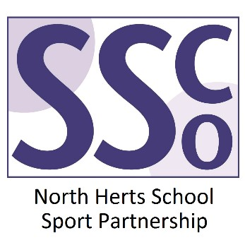

<School Name>

Participated in the North Herts School Sport Partnership
School Games U11 Basketball Competition

www.nhssp.co.uk | @NorthHertsSSP

