NHSSP Connect Festival

Age groups / categories

Year 6

Participants

The target group for the connect festivals are any Year 6 pupils whom it is expected will have difficulties settling into their new school. This may be for many reasons

- few children from their primary transferring to that school
- child may have difficulty in adapting to new situations/people
- generally nervous child who will worry in advance
- lower-level social skills which may hamper their settling in
- child with concerns about PE in their new school

This list is not exhaustive, it just gives some examples. You may decide that if a child has a real aversion/hatred of sports then this festival will not meet their needs.

Format

During National School Sport Week, there will be mutli-sports festivals hosted by local secondary schools for Year 6 pupils to help with the transition process.

Secondary Schools will use Year 7 Sports Leaders to organise and run activities.

The aim is to help familiarise pupils with their new school setting, hopefully meet and make new friends from other primary schools and provide Year 7 friendly faces they will see around school in September.

NHSSP Connect Festival

Registration Sheet

School name
Lead member of staff
Participation data
Gender¹
Boys - | Girls - | Other -
Ethnicity²
White (British/English) - | White (not British/English) - | Mixed Race -
Asian or British Asian - | Back or Black British - | Other -
SEND³
Total -

Please bring this sheet along with you and hand in to the event organiser upon arrival.

Be sure to let the event organiser know whether you have any pupils that cannot have their photograph taken. Photos are put onto the NHSSP website and twitter feed.

- We require data relating to gender at birth, or the child’s self-declared gender identity (if known and if different from birth-gender): i.e. a child born as a boy but identifying as a girl should be classified as a girl. “Other” should include those who prefer to self-describe as neither a boy or a girl, e.g. non-binary, gender-fluid and gender non-conforming.
- We require participation data relating to background and race to ensure that we reach a diverse population across School Games. We encourage all SGOs to collect and use data at a more granular level to help identify local opportunities and gaps and to ensure that an offer of a wide, diverse and inclusive provision for all. This data can be obtained from participating schools at an aggregated level, subject to data sharing agreements i.e. schools should be asked to share the total number of children participating in an event within each of the 6 groups.
- We require data at an overall “Special Educational Needs and/or Disability (SEND)” level for reporting purposes. However, we encourage SGOs to collect and use data at a more granular level to ensure a wide and diverse set of participants and inclusive provision. This data can be obtained from participating schools, subject to their data sharing agreements. Children included within the wide description of “SEND” include those with physical, cognitive, mental health/emotional and communication/social/relationships disabilities.

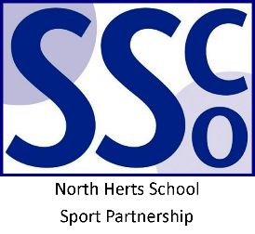

<Pupil Name>

Participated in the North Herts School Sport Partnership
Connect Festival

North Herts School Sport Partnership

www.nhssp.co.uk | @NorthHertsSSP

<Pupil Name>

Participated in the North Herts School Sport Partnership
Connect Festival

North Herts School Sport Partnership

www.nhssp.co.uk | @NorthHertsSSP

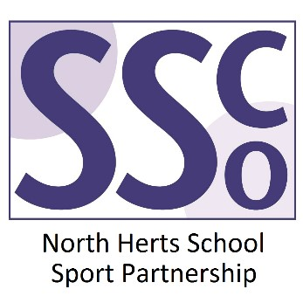

<School Name>

Participated in the North Herts School Sport Partnership
Connect Festival

www.nhssp.co.uk | @NorthHertsSSP

