NHSSP Inclusion Festival

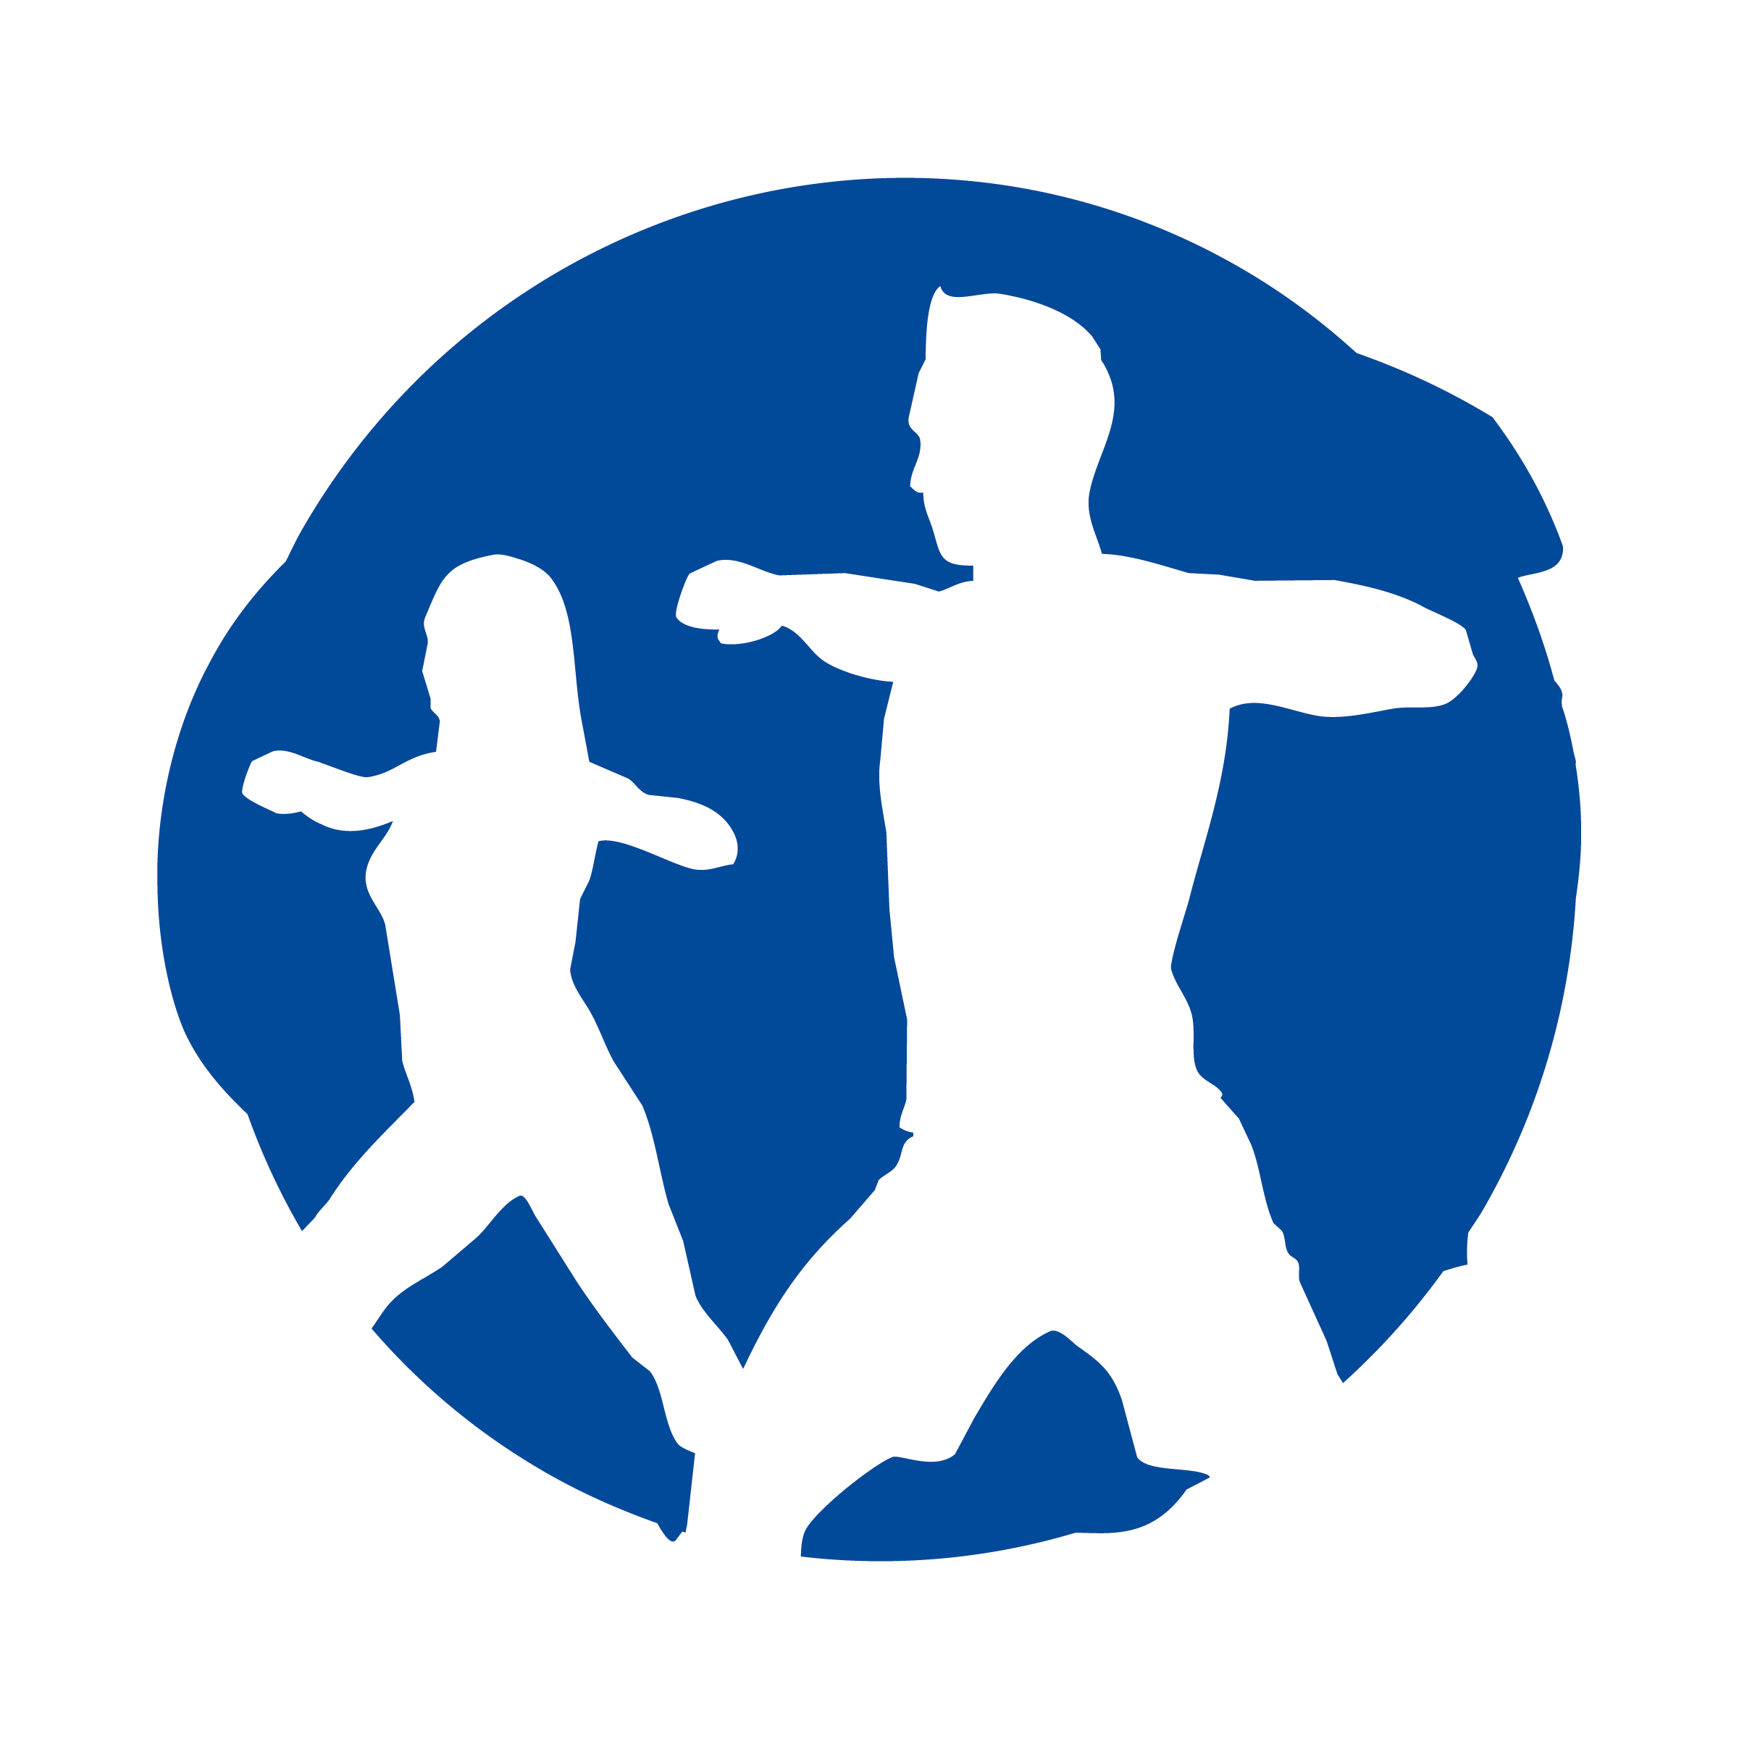
Age groups / categories
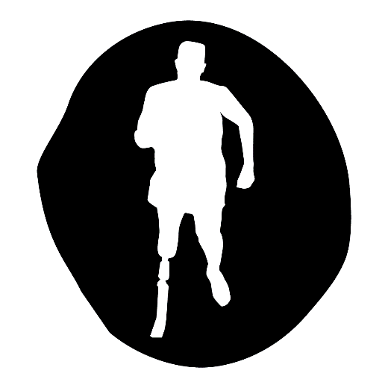
U11 – Year 4, 5 and 6
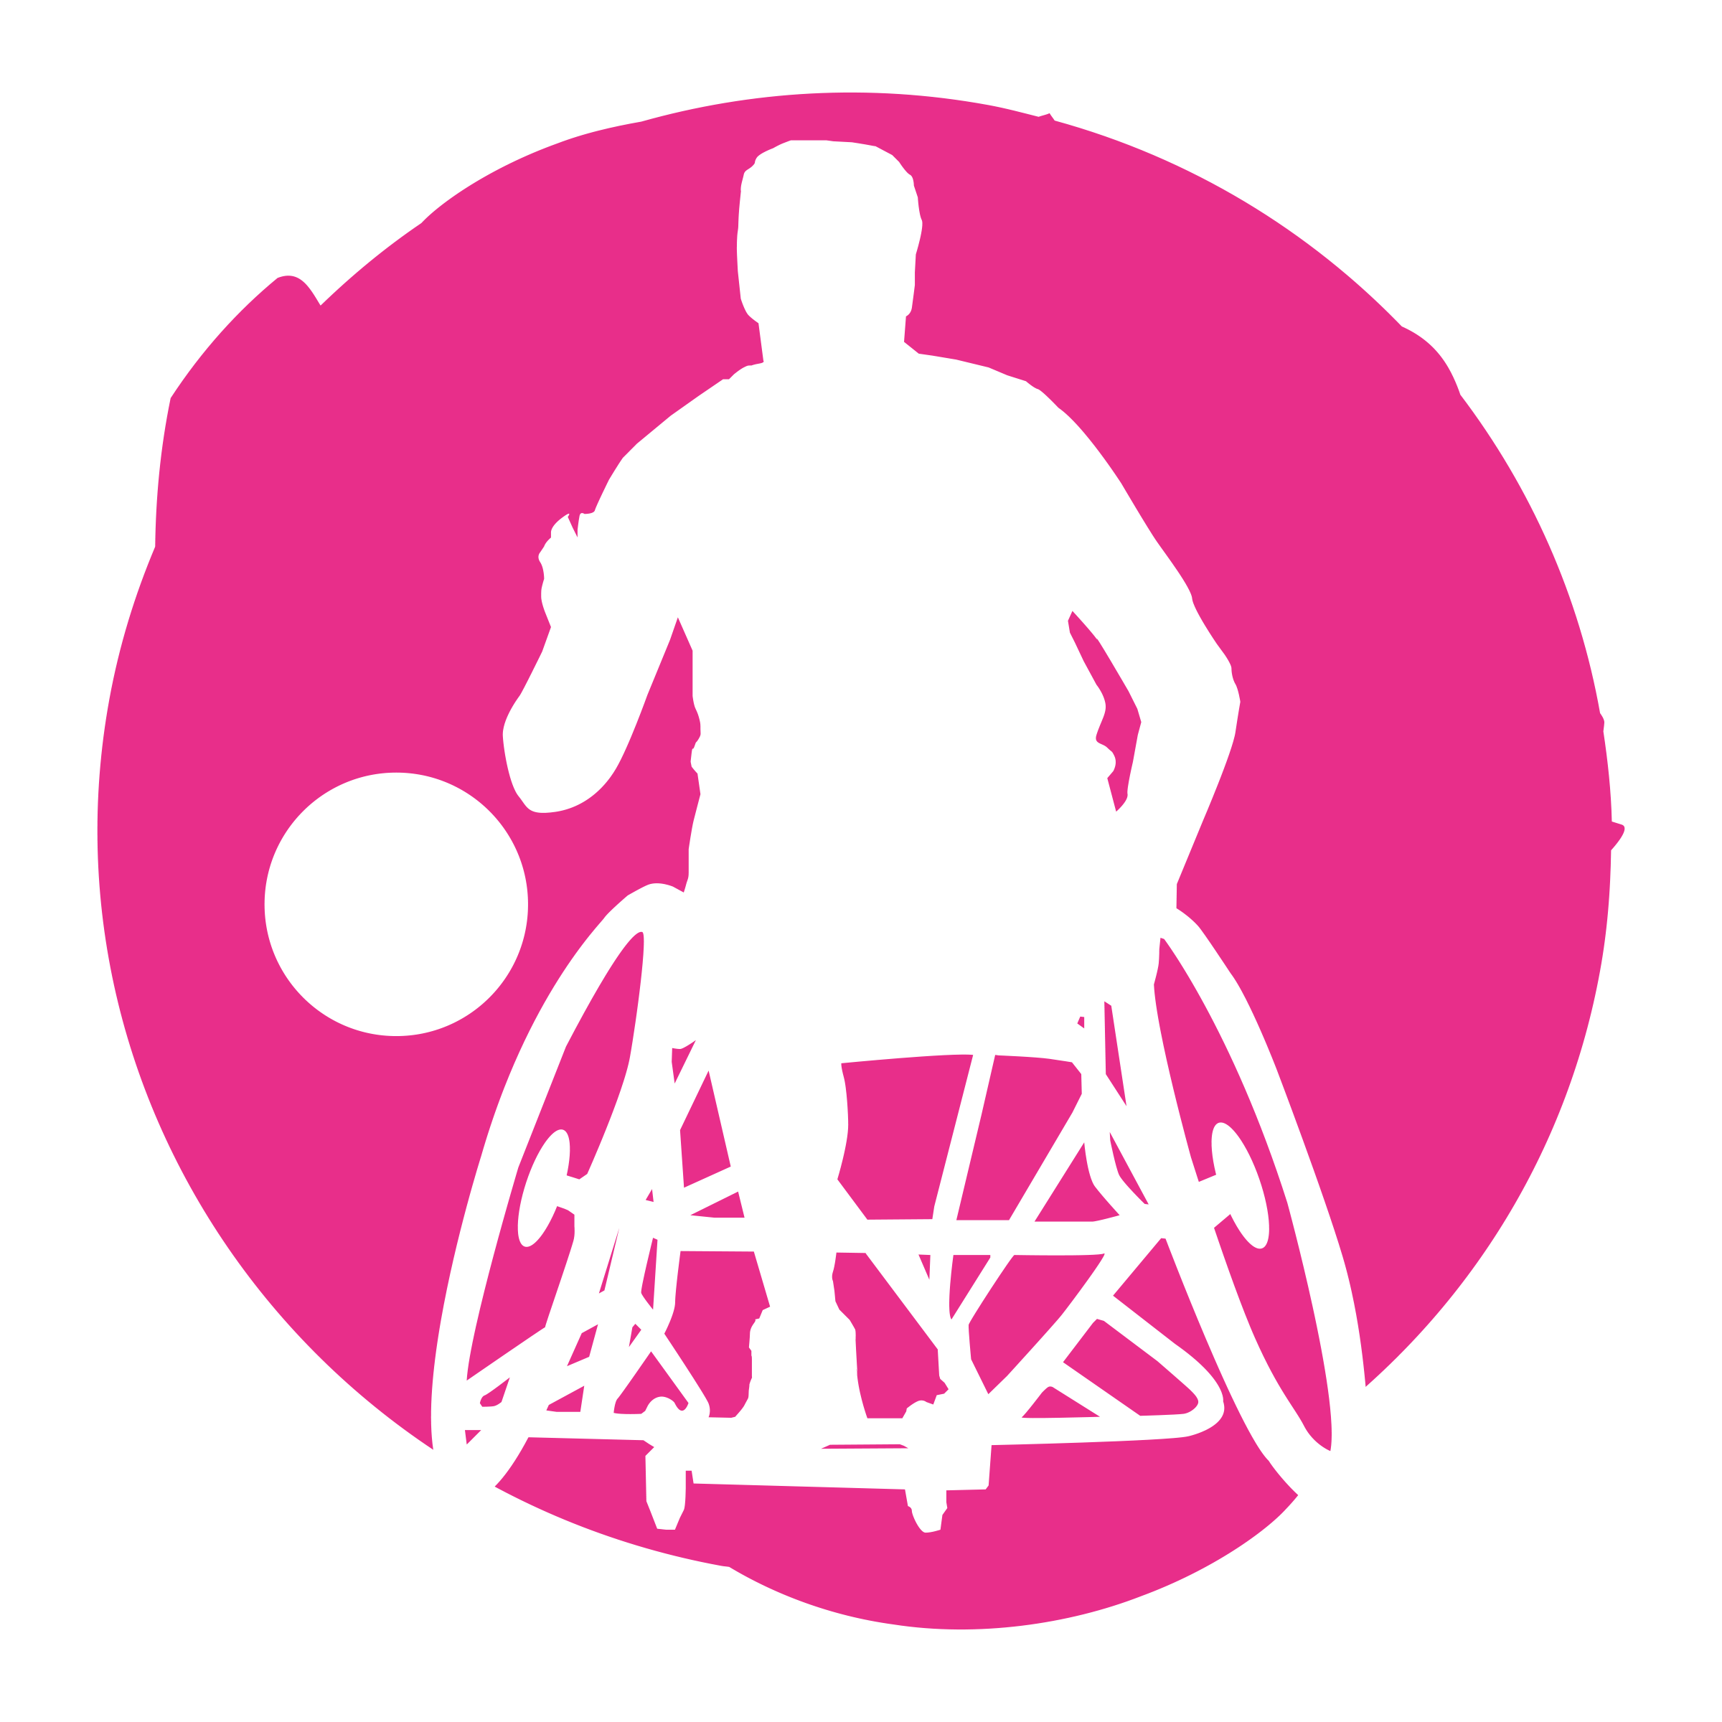
Participants

Schools can bring up to 8 children to attend.

This is an inclusive festival for pupils with additional support needs; pupils do not need to have long-term learning difficulties or disabilities. The festival will provide children with extra help / support so they can get the most out of the activities. You might decide to target two or three pupils, but they bring some friends along with them. Below are some examples of what can be meant by ‘additional needs’…

- Any learning disability or difficulty
  - ADHD, autism, dyslexia, dyspraxia, etc.
- Any physical disability or difficulty
  - Cerebral palsy, spinal cord injuries, etc.
- Any sensory impairments
  - Deaf, blind, hearing impairments, visual impairments, etc.
- Hypermobility
- Missed a lot of school due to illness or long-term condition
- Young carer
- Suffering a bereavement

The delivery team have a wealth of experience in working with children and young people with a variety of needs but please get in touch if you have any further questions or queries.

Format

The festival will be delivered in partnership with Herts Disability Sports Foundation and Imagination Dance CIC.

Pupils will take part in a carousel of adapted sports including Wheelchair Basketball, Dance, Boccia, and Athletics.

Sports Leaders will be stationed at each activity to help support pupils taking part.

Each school will also be allocated a Sports Leader to stay with them, helping escort them to their next activity.

Each participate will receive a goodie bag containing a t-shirt, medal, and flyers for appropriate exit route opportunities (clubs / holiday activities).

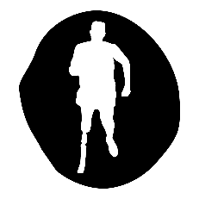
NHSSP Inclusion Festival

Registration Sheet

School name
Lead member of staff
Participation data
Gender¹
Boys - | Girls - | Other -
Ethnicity²
White (British/English) - | White (not British/English) - | Mixed Race -
Asian or British Asian - | Back or Black British - | Other -
SEND³
Total -

Please bring this sheet along with you and hand in to the event organiser upon arrival.

Be sure to let the event organiser know whether you have any pupils that cannot have their photograph taken. Photos are put onto the NHSSP website and twitter feed.

- We require data relating to gender at birth, or the child’s self-declared gender identity (if known and if different from birth-gender): i.e. a child born as a boy but identifying as a girl should be classified as a girl. “Other” should include those who prefer to self-describe as neither a boy or a girl, e.g. non-binary, gender-fluid and gender non-conforming.
- We require participation data relating to background and race to ensure that we reach a diverse population across School Games. We encourage all SGOs to collect and use data at a more granular level to help identify local opportunities and gaps and to ensure that an offer of a wide, diverse and inclusive provision for all. This data can be obtained from participating schools at an aggregated level, subject to data sharing agreements i.e. schools should be asked to share the total number of children participating in an event within each of the 6 groups.
- We require data at an overall “Special Educational Needs and/or Disability (SEND)” level for reporting purposes. However, we encourage SGOs to collect and use data at a more granular level to ensure a wide and diverse set of participants and inclusive provision. This data can be obtained from participating schools, subject to their data sharing agreements. Children included within the wide description of “SEND” include those with physical, cognitive, mental health/emotional and communication/social/relationships disabilities.

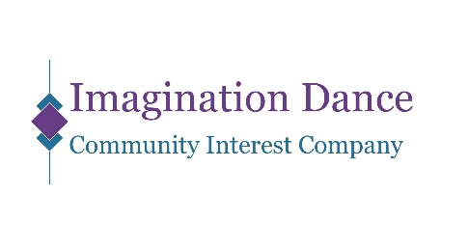
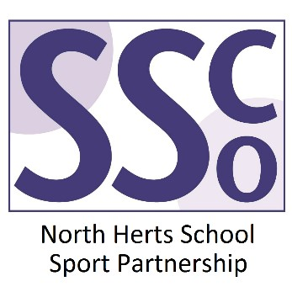
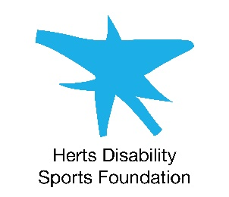

<Pupil Name>

Participated in the North Herts School Sport Partnership
Inclusion Festival

North Herts School Sport Partnership

www.nhssp.co.uk | @NorthHertsSSP

<Pupil Name>

Participated in the North Herts School Sport Partnership
Inclusion Festival

North Herts School Sport Partnership

www.nhssp.co.uk | @NorthHertsSSP

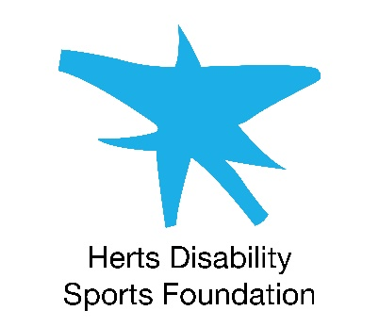
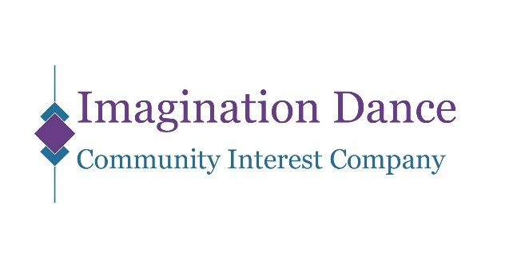

<School Name>

Participated in the North Herts School Sport Partnership
Inclusion Festival

www.nhssp.co.uk | @NorthHertsSSP

