NHSSP U11 Rounders Festival

Age groups / categories

U11 – Years 5 or 6

Available to enter:

- U11 Mixed

Team
Teams consist of a minimum of 9 players, maximum squad size of 12.
A maximum of 5 boys can be on the pitch at one time.

Format

Teams will have the rules explained at the start and play several friendly fixtures, depending on space / time
There will be no formal competition or overall winners
Matches consist of 1 innings of 20 good balls
Teams scoring the most rounders will the match

Rules
One team bats while the other team fields and bowl
The bowler bowls the ball underarm to the batter who hits the ball anywhere on the rounders pitch.
The batter runs around the outside of as many posts as possible before the fielders return the ball to touch the post the batter is heading for.
If the batter hits the ball backwards then they must wait at first post until the ball returns to the forward area.
If the batter reaches the second or third post in one hit, the batting team scores half a rounder.
If the batter reaches fourth post in one hit, the batting team scores one rounder.
A batter can wait at first, second or third post when it is not safe to run.
A batter is out if the fielding team catch the ball hit by the batter before it touches the ground or by touching the post the batter is heading to with the ball before the batter reaches it.
Complete rules and scorecards available from www.roundersengland.co.uk

Progression

There is no progression from this festival.

NHSSP U11 Rounders Festival

Registration Sheet

School name
Lead member of staff
Participation data
Gender¹
Boys - |  | Girls - | Other -
Ethnicity²
White (British/English) - | White (not British/English) - |  |  | Mixed Race -
Asian or British Asian - | Back or Black British - |  |  | Other -
SEND³
Total -

Please bring this sheet along with you and hand in to the event organiser upon arrival.

Be sure to let the event organiser know whether you have any pupils that cannot have their photograph taken. Photos are put onto the NHSSP website and twitter feed.

- We require data relating to gender at birth, or the child’s self-declared gender identity (if known and if different from birth-gender): i.e. a child born as a boy but identifying as a girl should be classified as a girl. “Other” should include those who prefer to self-describe as neither a boy or a girl, e.g. non-binary, gender-fluid and gender non-conforming.
- We require participation data relating to background and race to ensure that we reach a diverse population across School Games. We encourage all SGOs to collect and use data at a more granular level to help identify local opportunities and gaps and to ensure that an offer of a wide, diverse and inclusive provision for all. This data can be obtained from participating schools at an aggregated level, subject to data sharing agreements i.e. schools should be asked to share the total number of children participating in an event within each of the 6 groups.
- We require data at an overall “Special Educational Needs and/or Disability (SEND)” level for reporting purposes. However, we encourage SGOs to collect and use data at a more granular level to ensure a wide and diverse set of participants and inclusive provision. This data can be obtained from participating schools, subject to their data sharing agreements. Children included within the wide description of “SEND” include those with physical, cognitive, mental health/emotional and communication/social/relationships disabilities.

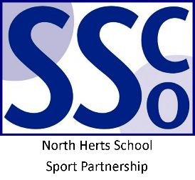

<Pupil Name>

Participated in the North Herts School Sport Partnership
U11 Rounders Festival

North Herts School Sport Partnership

www.nhssp.co.uk | @NorthHertsSSP

<Pupil Name>

Participated in the North Herts School Sport Partnership
U11 Rounders Festival

North Herts School Sport Partnership

www.nhssp.co.uk | @NorthHertsSSP

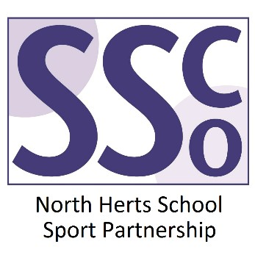

<School Name>

Participated in the North Herts School Sport Partnership
U11 Rounders Festival

www.nhssp.co.uk | @NorthHertsSSP

