NHSSP U11 Dodgeball Festival

Age groups / categories

U11 – Years 5 or 6

Available to enter:

- U11 Mixed

Team

Maximum squad of 8
Matches are 6-a-side

Format

One game lasts 2 minutes
A match is best of 3 games (total match time = 6 minutes)
To win a set, you must either eliminate all opposing players or have more players remaining on your side at the end of the 2 minutes.

Rules

3 foam dodgeballs are placed along the centre line
All 6 players on each team begin the game on their return line
On the whistle, 3 players from each team can race to the centre zone to retrieve a dodgeball
Once a dodgeball is retrieved at the start of the game, it must go back beyond the return line before it is live
Players are allowed to move whilst in possession of a dodgeball

- Live Balls - A ball is live until it hits a floor, wall or any other surrounding surface
- Hits – any player struck with a live ball (below head height) by an opposing player will be called out
- Catches – any catch on a live ball will be valid. The player who threw the caught ball will be called out and the catching team will gain one player from the outbox
- Blocking – players are able to use a ball in their possession to block an incoming ball. If the ball they are holding is knocked from their possession, they will be called out
- Lines – players are encouraged to stay inside the court markings. Players may leave the court to collect balls.
- Stalling – players should not intentionally stall the game. When a referee calls ‘play ball’, a team has 5 seconds to throw. If they do not, then players holding balls will be called out.

Progression

There is no progression for this event.

NHSSP U11 Dodgeball Festival

Registration Sheet

School name
Lead member of staff
Participation data
Gender¹
Boys - |  | Girls - | Other -
Ethnicity²
White (British/English) - | White (not British/English) - |  |  | Mixed Race -
Asian or British Asian - | Back or Black British - |  |  | Other -
SEND³
Total -

Please bring this sheet along with you and hand in to the event organiser upon arrival.

Be sure to let the event organiser know whether you have any pupils that cannot have their photograph taken. Photos are put onto the NHSSP website and twitter feed.

- We require data relating to gender at birth, or the child’s self-declared gender identity (if known and if different from birth-gender): i.e. a child born as a boy but identifying as a girl should be classified as a girl. “Other” should include those who prefer to self-describe as neither a boy or a girl, e.g. non-binary, gender-fluid and gender non-conforming.
- We require participation data relating to background and race to ensure that we reach a diverse population across School Games. We encourage all SGOs to collect and use data at a more granular level to help identify local opportunities and gaps and to ensure that an offer of a wide, diverse and inclusive provision for all. This data can be obtained from participating schools at an aggregated level, subject to data sharing agreements i.e. schools should be asked to share the total number of children participating in an event within each of the 6 groups.
- We require data at an overall “Special Educational Needs and/or Disability (SEND)” level for reporting purposes. However, we encourage SGOs to collect and use data at a more granular level to ensure a wide and diverse set of participants and inclusive provision. This data can be obtained from participating schools, subject to their data sharing agreements. Children included within the wide description of “SEND” include those with physical, cognitive, mental health/emotional and communication/social/relationships disabilities.

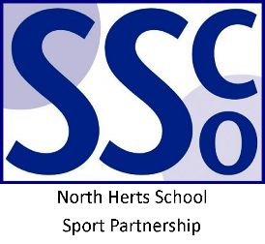

<Pupil Name>

Participated in the North Herts School Sport Partnership
U11 Dodgeball Festival

North Herts School Sport Partnership

www.nhssp.co.uk | @NorthHertsSSP

<Pupil Name>

Participated in the North Herts School Sport Partnership
U11 Dodgeball Festival

North Herts School Sport Partnership

www.nhssp.co.uk | @NorthHertsSSP

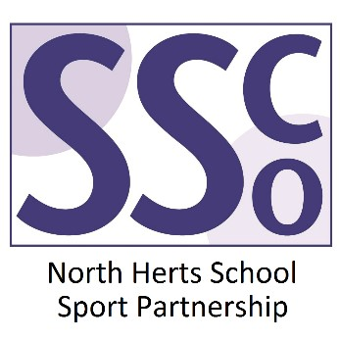

<School Name>

Participated in the North Herts School Sport Partnership
U11 Dodgeball Festival

www.nhssp.co.uk | @NorthHertsSSP

