NHSSP Multi-Skills Festivals

Age groups / categories

EYFS
Key Stage 1 - Year 1 or 2
U9 – Year 3 or 4

Participants

Schools can bring up to 8 children to participate in the festival.

This event is aimed at children who have not / are not likely to represent their school in other competitions or festivals.
These may be pupils who attend your Change 4 Life Club or similar.

Multi-skills and multi-sports based. Working on basic agility, balance, and coordination. Basic movement and sports skills from playground games to various sports such as athletics, tennis, and football.

Format

Participants will be split into groups and take part in a carousel of activities, working on a few different skills.

There will be no formal competition.

Sports Leaders from the host school will be running the activities.

NHSSP Multi-Skills Festival

Registration Sheet

School name
Lead member of staff
Participation data
Gender¹
Boys - | Girls - | Other -
Ethnicity²
White (British/English) - | White (not British/English) - | Mixed Race -
Asian or British Asian - | Back or Black British - | Other -
SEND³
Total -

Please bring this sheet along with you and hand in to the event organiser upon arrival.

Be sure to let the event organiser know whether you have any pupils that cannot have their photograph taken. Photos are put onto the NHSSP website and twitter feed.

- We require data relating to gender at birth, or the child’s self-declared gender identity (if known and if different from birth-gender): i.e. a child born as a boy but identifying as a girl should be classified as a girl. “Other” should include those who prefer to self-describe as neither a boy or a girl, e.g. non-binary, gender-fluid and gender non-conforming.
- We require participation data relating to background and race to ensure that we reach a diverse population across School Games. We encourage all SGOs to collect and use data at a more granular level to help identify local opportunities and gaps and to ensure that an offer of a wide, diverse and inclusive provision for all. This data can be obtained from participating schools at an aggregated level, subject to data sharing agreements i.e. schools should be asked to share the total number of children participating in an event within each of the 6 groups.
- We require data at an overall “Special Educational Needs and/or Disability (SEND)” level for reporting purposes. However, we encourage SGOs to collect and use data at a more granular level to ensure a wide and diverse set of participants and inclusive provision. This data can be obtained from participating schools, subject to their data sharing agreements. Children included within the wide description of “SEND” include those with physical, cognitive, mental health/emotional and communication/social/relationships disabilities.

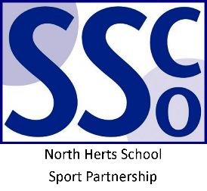

<Pupil Name>

Participated in the North Herts School Sport Partnership
Multi-Skills Festival

North Herts School Sport Partnership

www.nhssp.co.uk | @NorthHertsSSP

<Pupil Name>

Participated in the North Herts School Sport Partnership
Multi-Skills Festival

North Herts School Sport Partnership

www.nhssp.co.uk | @NorthHertsSSP

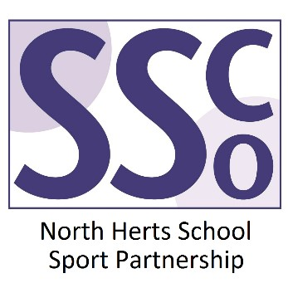

<School Name>

Participated in the North Herts School Sport Partnership
Multi-Skills Festival

www.nhssp.co.uk | @NorthHertsSSP

