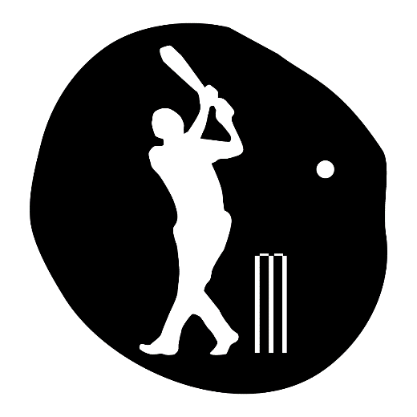
NHSSP Cricket Competitions

Age groups / categories

U9 – Year 3 or 4
U11 – Year 5 or 6

Available to enter:

- U9 Small Schools – up to 1 form entry schools
- U9 Large Schools - more than 1 form entry schools
- U11 Mixed or Boys Only
- U11 Girls Only

Team

U9
Maximum squad of 8 made up of 4 boys and 4 girls*
Matches are 6-a-side
* All girls’ schools are exempt from this and may enter a full squad of girls

U11
Matches are 8-a-side
Maximum squad size is 10

Format

U9 Rapid Fire 6Ts Cricket
Small Schools and Large Schools will compete in separate competitions.
Teams will be put into groups – dependant on entries
3 points for a win, 2 for a draw, 1 point for a loss
If teams are tied, we will refer to runs scored, runs against, runs difference, the score between the teams

- Set of stumps (10-15m apart)
- Batters waiting area
- 6 tees set up on 6 flat markers with 6 soft balls on, 2 batters ready
- Fielding line – fielders must remain still and behind the line until all 6 balls have been struck. Fielders return to the line once they’ve replaced all the balls
- 6 fielders in play
- Bonus scoring zones (1.5m) balls that pass through the gate score an additional 4 runs

U11 Dynamos Cricket
Dynamos Schools is building on the success of Kwik Cricket.
5 balls per player then the next fielder rotates to bowl.
Batting pairs face 10 balls. Umpires should use their discretion to swap batters, so each is given the opportunity to contribute.
Scoring is done via the Countdown Cricket app: for android click here or iOS click here.
On the day, teams will be split into pools, culminating in a final.

Rules

U9 Rapid Fire 6Ts Cricket
The fielders wait behind the fielding line
The batter hits 3 balls in succession from a tee, two batters play at once
There may be some gates for the batters to aim at to score points
Once all 6 balls have been hit, they begin to run between a set of stumps
The fielders can only start moving and collecting the balls once all the balls have been hit
The fielders race to replace all the balls and tees, and return behind the fielding line
The scores are recorded, and it is time for the next batters
When all the batters have had a turn, the fielding team becomes the batting team and tries to beat the score

U11 Dynamos Cricket
Runs are scored by hitting the ball past (4 runs) or over (6 runs) the boundary or completing runs between the wickets.
No-balls and wide balls are scored as 2 runs. Batters shouldn’t hit these balls. There are no extra balls bowled. Instead, following a no-ball or a wide ball, a free hit is taken from the batting tee. Any runs scored from this hit are added to the total (e.g.: 2 runs for the no-ball / wide, plus 1 run from the ‘free hit’ = 3 runs)
If a player is bowled, caught, or run out the batter’s swap ends and continue. 5 runs are added to the fielding team.
For full rules please click here.

Progression

Winning teams from each category will be invited to represent Team North Herts at the Herts School Games Finals.

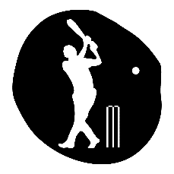
NHSSP Cricket Competition

Registration Sheet

School name
Lead member of staff
Participation data
Gender¹
Boys - |  | Girls - | Other -
Ethnicity²
White (British/English) - | White (not British/English) - |  |  | Mixed Race -
Asian or British Asian - | Back or Black British - |  |  | Other -
SEND³
Total -

Please bring this sheet along with you and hand in to the event organiser upon arrival.

Be sure to let the event organiser know whether you have any pupils that cannot have their photograph taken. Photos are put onto the NHSSP website and twitter feed.

- We require data relating to gender at birth, or the child’s self-declared gender identity (if known and if different from birth-gender): i.e. a child born as a boy but identifying as a girl should be classified as a girl. “Other” should include those who prefer to self-describe as neither a boy or a girl, e.g. non-binary, gender-fluid and gender non-conforming.
- We require participation data relating to background and race to ensure that we reach a diverse population across School Games. We encourage all SGOs to collect and use data at a more granular level to help identify local opportunities and gaps and to ensure that an offer of a wide, diverse and inclusive provision for all. This data can be obtained from participating schools at an aggregated level, subject to data sharing agreements i.e. schools should be asked to share the total number of children participating in an event within each of the 6 groups.
- We require data at an overall “Special Educational Needs and/or Disability (SEND)” level for reporting purposes. However, we encourage SGOs to collect and use data at a more granular level to ensure a wide and diverse set of participants and inclusive provision. This data can be obtained from participating schools, subject to their data sharing agreements. Children included within the wide description of “SEND” include those with physical, cognitive, mental health/emotional and communication/social/relationships disabilities.

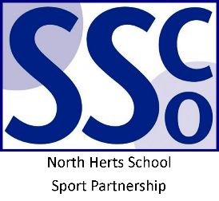
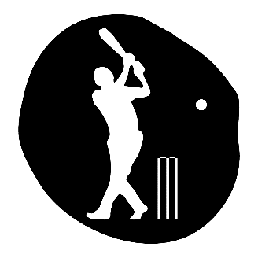

<Pupil Name>

Participated in the North Herts School Sport Partnership
School Games Cricket Competition

North Herts School Sport Partnership

www.nhssp.co.uk | @NorthHertsSSP

<Pupil Name>

Participated in the North Herts School Sport Partnership
School Games Cricket Competition

North Herts School Sport Partnership

www.nhssp.co.uk | @NorthHertsSSP

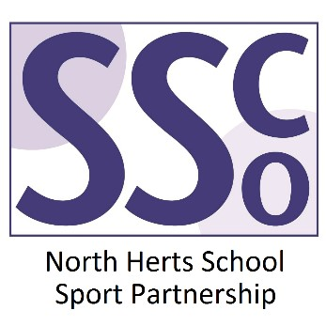

<School Name>

Participated in the North Herts School Sport Partnership
School Games Cricket Competition

www.nhssp.co.uk | @NorthHertsSSP

