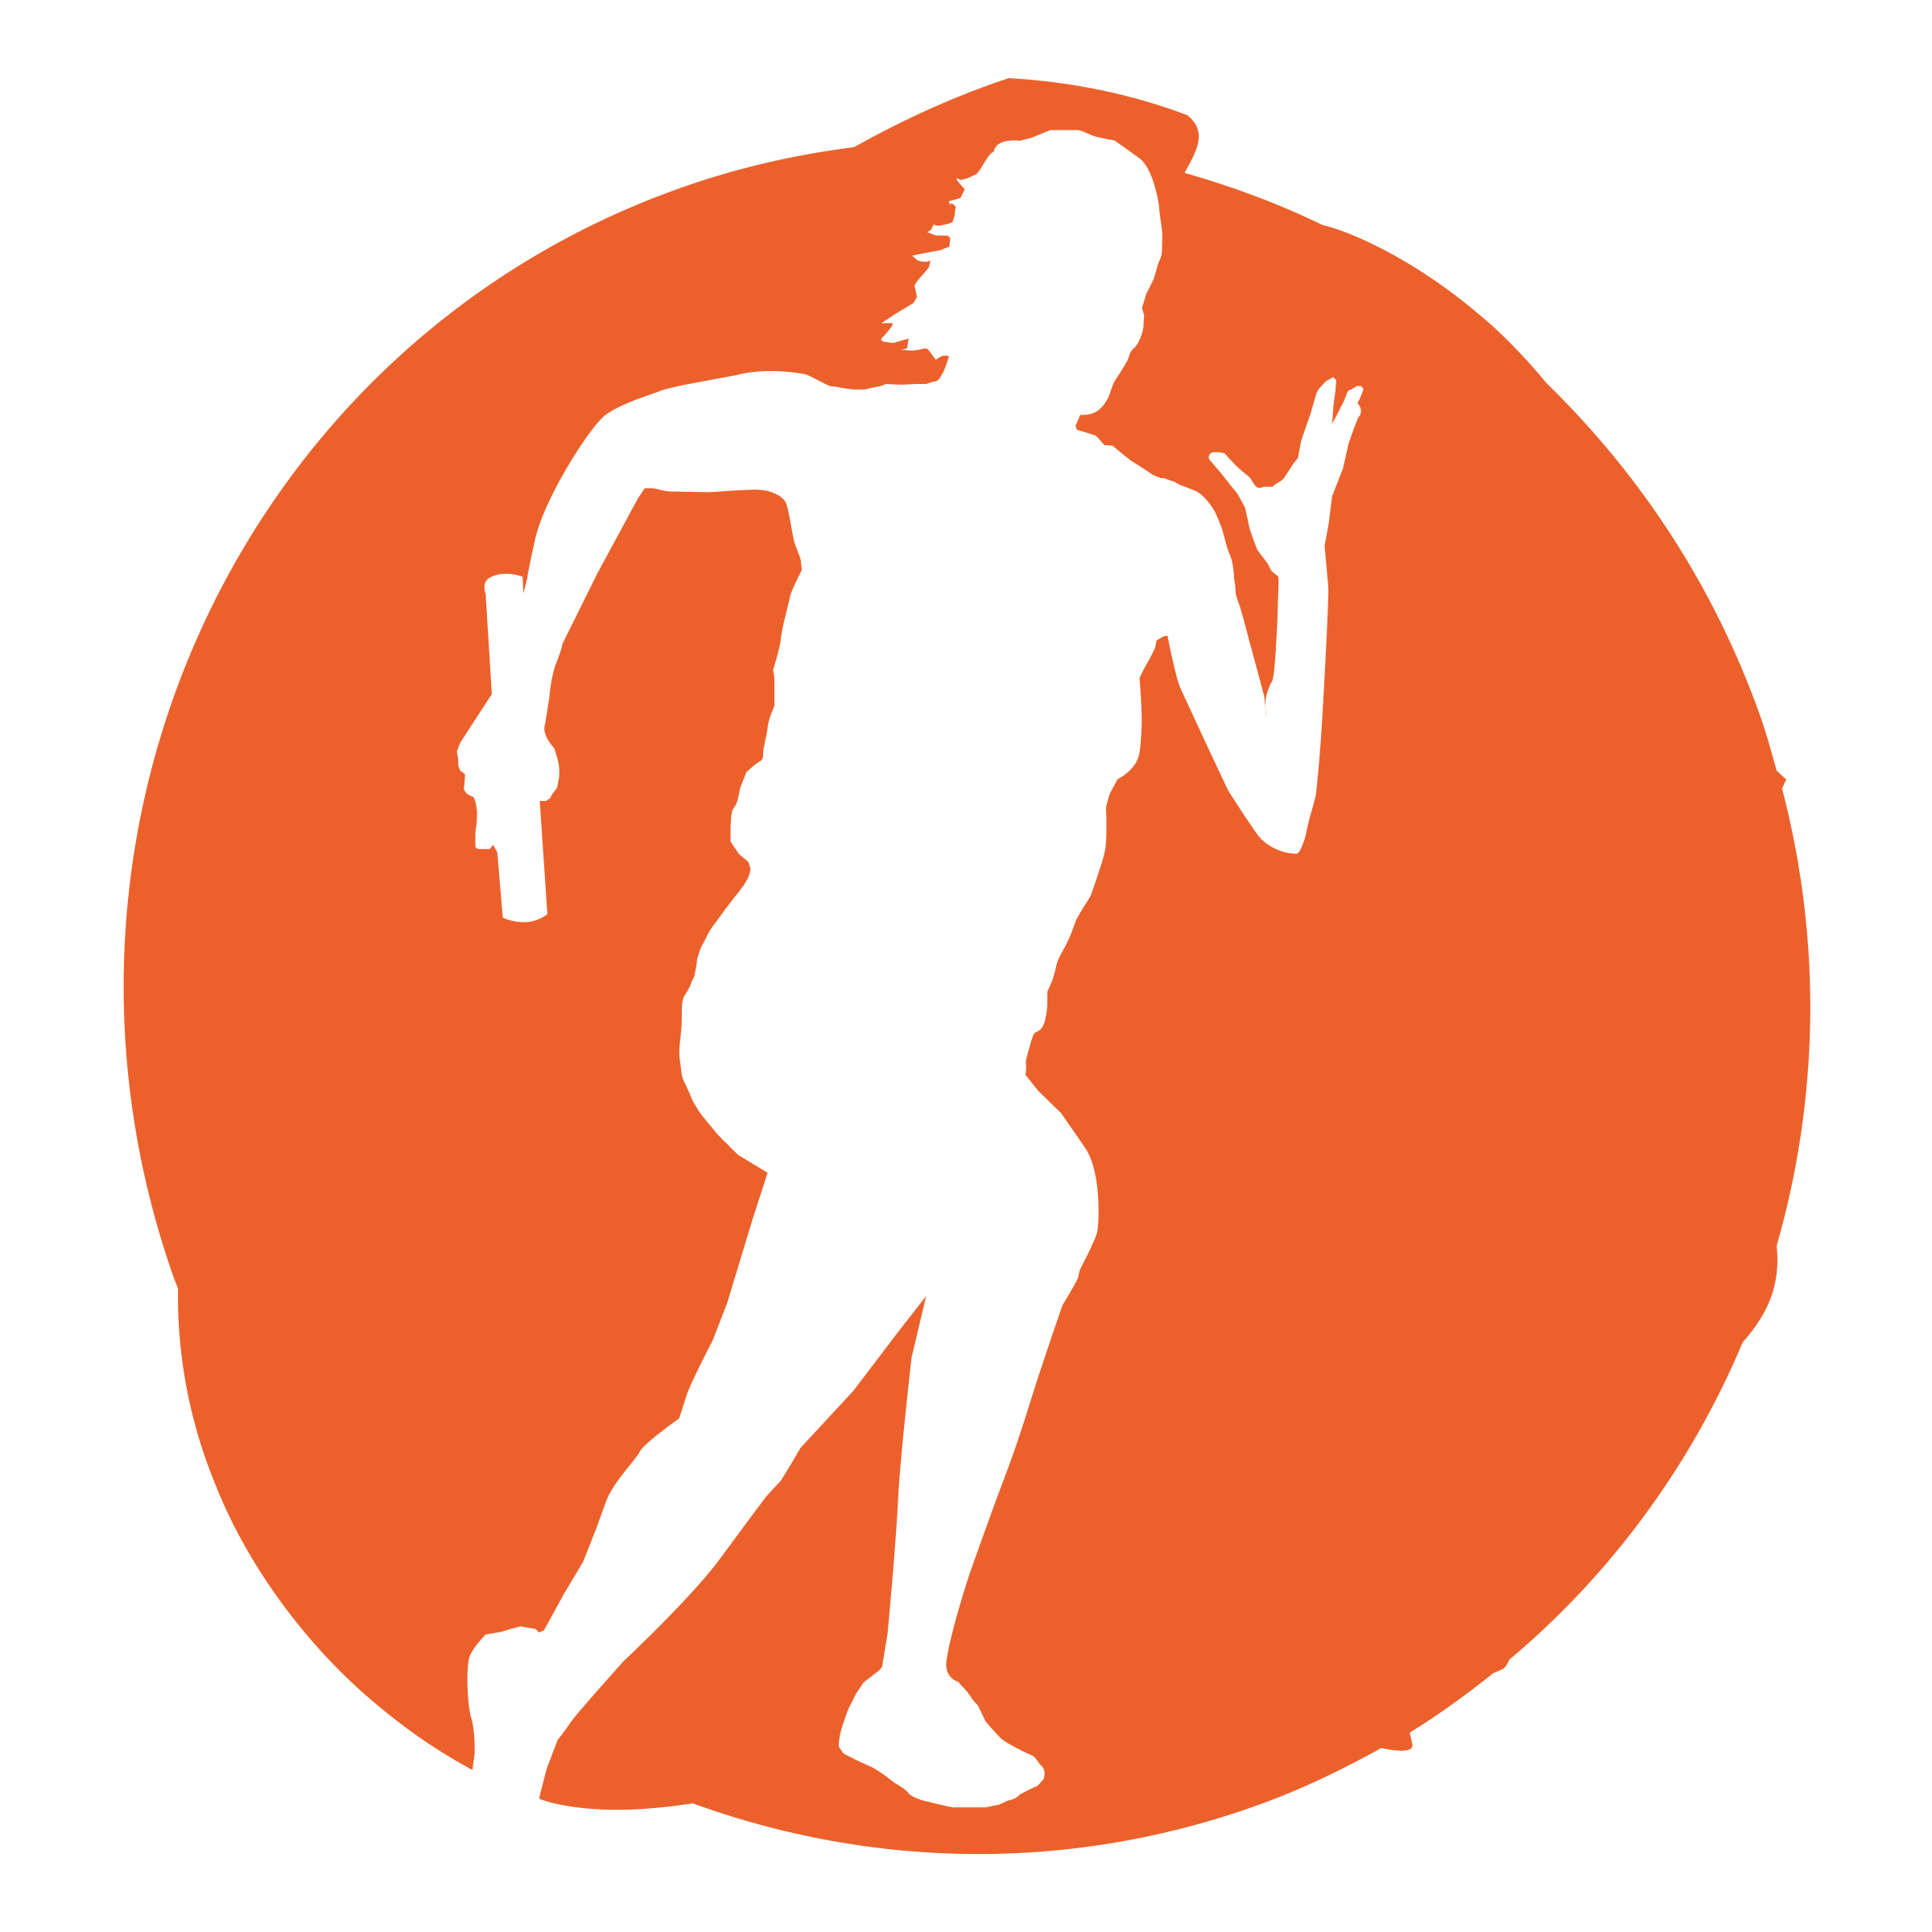
NHSSP Cross Country Competition

Age groups / categories

U11 – Years 5 and 6

Available to enter:

- Year 5 Girls
- Year 5 Boys
- Year 6 Girls
- Year 6 Boys

Team

Up to 4 runners per team (16 per school)

Format

Teams with the most points will win that category
The top 3 runners will score points for their team

Year 5
Athletes will run a half mile course

Year 6
Athletes will run a mile course

Rules

All the athletes will walk the course before the competition starts
All schools must stay behind the taped course and leave a clear path to the score table
Year 5 athletes complete one lap of the course, year 6 complete 2 laps of the course
As the athletes finish, they will be given a raffle ticket with their position on which needs to be taken to the score table immediately

Progression

There is no progression directly on from these festivals. There is a Herts Schools competition which usually takes place at the end of January or beginning of February which individuals or teams are welcome to enter independently.

NHSSP Cross Country Competition

Registration Sheet

School name
Lead member of staff
Participation data
Gender¹
Boys - | Girls - | Other -
Ethnicity²
White (British/English) - | White (not British/English) - | Mixed Race -
Asian or British Asian - | Back or Black British - | Other -
SEND³
Total -

Please bring this sheet along with you and hand in to the event organiser upon arrival.

Be sure to let the event organiser know whether you have any pupils that cannot have their photograph taken. Photos are put onto the NHSSP website and twitter feed.

- We require data relating to gender at birth, or the child’s self-declared gender identity (if known and if different from birth-gender): i.e. a child born as a boy but identifying as a girl should be classified as a girl. “Other” should include those who prefer to self-describe as neither a boy or a girl, e.g. non-binary, gender-fluid and gender non-conforming.
- We require participation data relating to background and race to ensure that we reach a diverse population across School Games. We encourage all SGOs to collect and use data at a more granular level to help identify local opportunities and gaps and to ensure that an offer of a wide, diverse and inclusive provision for all. This data can be obtained from participating schools at an aggregated level, subject to data sharing agreements i.e. schools should be asked to share the total number of children participating in an event within each of the 6 groups.
- We require data at an overall “Special Educational Needs and/or Disability (SEND)” level for reporting purposes. However, we encourage SGOs to collect and use data at a more granular level to ensure a wide and diverse set of participants and inclusive provision. This data can be obtained from participating schools, subject to their data sharing agreements. Children included within the wide description of “SEND” include those with physical, cognitive, mental health/emotional and communication/social/relationships disabilities.

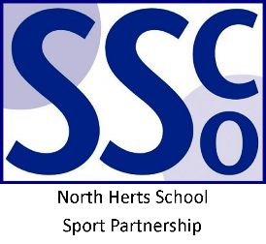

<Pupil Name>

Participated in the North Herts School Sport Partnership
Cross Country Competition

North Herts School Sport Partnership

www.nhssp.co.uk | @NorthHertsSSP

<Pupil Name>

Participated in the North Herts School Sport Partnership
Cross Country Competition

North Herts School Sport Partnership

www.nhssp.co.uk | @NorthHertsSSP

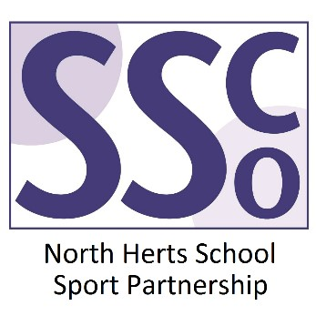

<School Name>

Participated in the North Herts School Sport Partnership
Cross Country Competition

www.nhssp.co.uk | @NorthHertsSSP

