NHSSP Hockey

Age groups / categories

U11 – Year 5 or 6

Available to enter:

- Mixed U11 Hockey Festival
- Mixed U11 Hockey Competition

Team

Maximum squad of 10
Matches are 7-a-side
There should always be at least 3 girls and 3 boys on the pitch at a time* the 7th player may be a girl or boy.
* All girls’ schools are exempt from this and may enter a full squad of girls
No goalkeepers

Format

Festival
Teams will do some warm-up and skill activities led by Sports Leaders
Teams will then play a few friendly games
The rules below will be explained to the participants

Competition
Teams will be put into groups – dependant on numbers
Matches will be 10 minutes one way - if time allows
3 points for a win, 2 points for a draw, 1 point for a loss
If the points are tied at the end of the round robin the winner will be decided by the following process:
Goal difference, Goals scored, Goal conceded, Result between the two teams

Rules

Self-passing is allowed
Both teams must be 3m from free hits
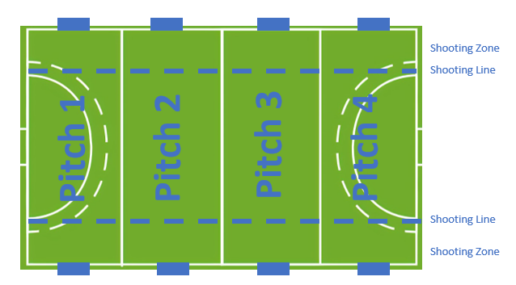
If the ball is stopped going into the goal by feet or hands the goal is still given
Long corners are taken from the shooting zone line, in line with where the ball went off
No penalty corners or flicks
Substitutions can be made at any time
Players must be inside the shooting zone to score a goal
The stick should not go higher than the knee
The ball should not be lifted
Shin pads must be worn, gumshields are advised
Advantage will be played where possible to allow the game to flow

Power Play - If a team goes 4 goals down you will be able to bring on an eighth player, so 8 v 7. If you score, so it is 3 goals down, the eighth player leaves the pitch. If you go 6 goals down you can bring on another player, so 9 v 7, until it is 4 goals down, then one player leaves.
Please note only Astroturf and normal trainers are to be worn - NO studded footwear will be allowed.
Pitch size will be from side line to side line, across the width of an astro. Therefore, four pitches can be marked out on one astro.
Please bring bibs with you in case of a kit clash. If you have hockey sticks, please bring these with you. Plastic Unihoc sticks are not appropriate to use.
Progression

Festival
No progression

Competition
The winning team will be invited to represent Team North Herts at the Herts School Games Finals.

The festival is an Aspire and Develop Event

The competition is a Compete Event

NHSSP U11 Hockey

Registration Sheet

School name
Lead member of staff
Participation data
Gender¹
Boys - |  | Girls - | Other -
Ethnicity²
White (British/English) - | White (not British/English) - |  |  | Mixed Race -
Asian or British Asian - | Back or Black British - |  |  | Other -
SEND³
Total -

Please bring this sheet along with you and hand in to the event organiser upon arrival.

Be sure to let the event organiser know whether you have any pupils that cannot have their photograph taken. Photos are put onto the NHSSP website and twitter feed.

- We require data relating to gender at birth, or the child’s self-declared gender identity (if known and if different from birth-gender): i.e. a child born as a boy but identifying as a girl should be classified as a girl. “Other” should include those who prefer to self-describe as neither a boy or a girl, e.g. non-binary, gender-fluid and gender non-conforming.
- We require participation data relating to background and race to ensure that we reach a diverse population across School Games. We encourage all SGOs to collect and use data at a more granular level to help identify local opportunities and gaps and to ensure that an offer of a wide, diverse and inclusive provision for all. This data can be obtained from participating schools at an aggregated level, subject to data sharing agreements i.e. schools should be asked to share the total number of children participating in an event within each of the 6 groups.
- We require data at an overall “Special Educational Needs and/or Disability (SEND)” level for reporting purposes. However, we encourage SGOs to collect and use data at a more granular level to ensure a wide and diverse set of participants and inclusive provision. This data can be obtained from participating schools, subject to their data sharing agreements. Children included within the wide description of “SEND” include those with physical, cognitive, mental health/emotional and communication/social/relationships disabilities.

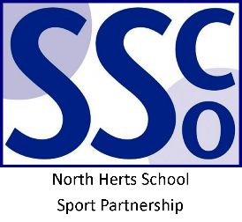
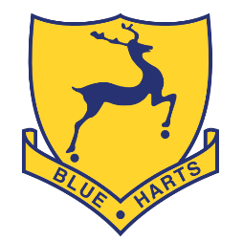

<Pupil Name>

Participated in the North Herts School Sport Partnership
School Games Hockey Event

North Herts School Sport Partnership

www.nhssp.co.uk | @NorthHertsSSP

<Pupil Name>

Participated in the North Herts School Sport Partnership
School Games Hockey Event

North Herts School Sport Partnership

www.nhssp.co.uk | @NorthHertsSSP

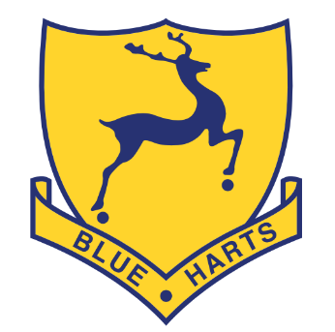
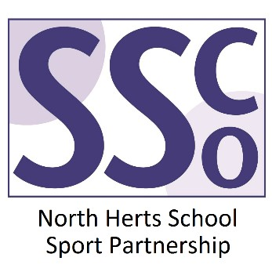

<School Name>

Participated in the North Herts School Sport Partnership
School Games Hockey Event

www.nhssp.co.uk | @NorthHertsSSP

